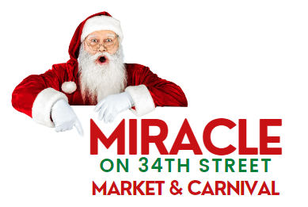
Saturday, December 3rd 10 am til 3 pm
Lutheran North Academy 1130 W 34th Street Houston, TX 77018

We Need You, Become a Sponsor Today!

Join us for our 1st annual festival and holiday market that is family-friendly in our community.
We need you to make this event a great success and we look forward to seeing you on Saturday, December 3, 2022, from 10 am – 3 pm. With that, we need area businesses and surrounding communities around Lutheran North Academy to participate and support this
great event. Don’t miss the opportunity to be a big part of this 1st annual tradition!
Miracle On 34th Street Market & Carnival
SPONSORSHIP PACKAGES:

Platinum ($1200) (SOLD OUT)
• Company information on ALL event printing (ads, posters, tickets) and digital
materials (website, event web page, school digital displays – 10 mos.)
• Banner signage, digital display, and event announcement
FREE Admission
Holiday Shopping
Kid Zone
Food
Bounce Houses
Carnival Games
Family Fun
Festival Booth Sponsorship ($125)
• Company information on event webpage & event announcement
• Small signage at game/attraction booth

For questions @ lna.ptl@leahnorth.org or, please select your level of support on the form below and mail it with your check payable to Lutheran North Academy or LEAH.
Follow us on social media

Date: ____________ Gift Amount: ____________
Note: Lutheran North Academy is a 501(c)3 non-profit organization. Your gift is deductible to the
fullest extent allowed by law. Please keep this for your records.
Please keep top portion and return bottom portion. Cut along line

LUTHERAN NORTH ACADEMY SPONSORSHIP INFORMATION
* Sponsors will also receive recognition based upon the level of sponsorship selected.
Note: Deadline for sponsorships is November 14th to allow time to prepare items needed for the festival.
Please enter your contact information below so we can confirm your contribution.

Please complete information below
Your Name & Title:
Name:
Company Name:
Address:
Phone#:
Email:

PAYMENT
Visa MasterCard Amex Eventbrite Link

Amount to Charge $
Name on Card
Card Number
Exp Date 3/4 digit #
Billing Address

All financial information will be kept confidential

Please mail form & check to: LEAH North Academy, Attn: Festival
1130 W 34th St, Houston, TX 77018

Thanks again for your generous support of Lutheran North Academy!!!
For questions contact Lonnie Pena at 713-240-7662 or lna.ptl@leahnorth.org

